Intelligent Resume Analysis and Job Recommendation System Using Retrieval-Augmented Generation and Large Language
1stAnsari Moinuddin M  26MAG0043  M.Sc. Artificial Intelligence and Machine Learning  Vellore Institute of Technology  Vellore, Tamil Nadu, India | 2nd Gayathri A  Faculty  School of Computer Science and Engineering  Vellore Institute of Technology  Vellore, Tamil Nadu, India | 3rd Mohammad Saad  26MAG0061  M.Sc. Artificial Intelligence and Machine Learning Vellore Institute of Technology  Vellore, Tamil Nadu, India | 4th Iman Huda  26MAG0095  M.Sc. Artificial Intelligence and Machine Learning Vellore Institute of Technology  Vellore, Tamil Nadu, India

Abstract— Traditional resume screening systems often rely on keyword matching, which may fail to identify relevant skills expressed in different ways and provide limited explanations for job recommendations. This paper presents VECTORAI ResumeIntelligence,an implemented system that combines resume analysis, natural language processing (NLP), semantic search, and AI-assisted career guidance. The system accepts resumes in PDF and image formats, extracts relevant information, identifies skills and qualifications, and compares candidate profiles with job descriptions using sentence embeddings and vector-based retrieval. It also provides resume quality scoring, job recommendations, skill-gap analysis, explanations of matching results, resume improvement suggestions, and career guidance. The application uses React and TypeScript for the frontend, FastAPI and Python for the backend, SQLite for application data, and ChromaDB for vector storage and retrieval. Optional Gemini and Ollama integrations support AI-assisted features. By bringing resume evaluation, job matching, and career support into one application, the system helps users understand their suitability for job opportunities and identify areas for improvement.
Keywords—Resume Analysis, Job Recommendation, Natural Language Processing, Sentence Embeddings, Semantic Search, Large Language Models, Skill-Gap Analysis.

I.LITERATURE SURVEY
Recent research from 2023 to 2026 has explored automated resume analysis, semantic job matching, AI-based recommendations, and personalized career guidance. The selected studies are grouped into three areas: resume analysis and job recommendation, semantic matching techniques, and explainable or AI-assisted career support.

A.Resume Analysis and Job Recommendation
The study An Advanced Real-Time Job Recommendation System and Resume Analyser (2023) combines natural language processing (NLP), named entity recognition, GloVe embeddings, and similarity measures to analyse resumes and recommend jobs. It demonstrates how information extraction and text similarity can support automated recruitment.
ResumAI: Revolutionizing Automated Resume Analysis and Recommendation with Multi-Model Intelligence (2023) explores NLP and machine-learning methods for resume classification and recommendation. Its use of multiple models highlights the value of combining text-processing and classification techniques.
In 2024, Career Craft AI: A Personalized Resume Analysis and Job Recommendations System investigated NLP-based resume analysis, job recommendations, and resume improvement. Another study, Development of a Recommendation System for Resume Tracking and Job Suggestions, explored the use of generative AI, NLP, and job information collected from online sources.

B. Semantic Resume–Job Matching
Job Recommendation System based on Resume using Natural Language Processing and Distance-based Algorithm (2024) examined resume extraction and distance-based comparison methods, including Word2Vec and TF-IDF-based approaches. The study illustrates how different similarity measures can affect job-matching results.
Huang, Liu, and Lee (2023) proposed an attentive deep neural network that considers implicit relationships within resumes for talent recommendation. Their work highlights the importance of representing relationships between candidate attributes rather than relying only on individual keywords.
A 2025 study, Enhancing Job Recommendations with LLM-Based Resume Completion: A Behavior-Denoised Alignment Approach, investigated how language-model-assisted resume completion can improve job recommendations. In 2026, Nexus: A Multi-Modal Framework for Semantic Job Matching and AI-Driven Resume Analysis combined document extraction, OCR, semantic matching, and AI-generated feedback. These studies demonstrate the growing interest in combining semantic representations with richer resume-processing pipelines.

C. Explainable and AI-Assisted Career Support
AI-Powered Model for Intelligent Resume Recommendation and Feedback (2024) explored BERT-based recommendations and feedback for improving alignment between resumes and job requirements.
A 2025 study titled Intelligent Resume Analysis with Real-Time Multi-Platform Job Matching presented an integrated approach to resume parsing, job matching, and career advice. In 2026, Explainable and Scalable Job Recommendation System using Transformer-Based Text Summarization, Cross-Encoder Semantic Similarity, and Ensemble Learning investigated semantic scoring and explainability methods for job recommendations.
Research published in 2026 on AI-Powered Skill Gap Analysis and Career Path Recommendation System Using Hybrid Semantic and Ontology-Based Matching also addressed missing-skill identification and career guidance. This is relevant to systems that go beyond ranking jobs and help candidates understand what they need to improve.

Table I.

Summary of Related Studies
Study | Publisher / Year | Main focus
An Advanced Real-Time Job Recommendation System and Resume Analyser | IEEE, 2023 | NLP, GloVe embeddings and resume matching
ResumAI: Revolutionizing Automated Resume Analysis and Recommendation with Multi-Model Intelligence | IEEE, 2023 | Resume classification and recommendation
Talent Recommendation Based on Attentive Deep Neural Network and Implicit Relationships of Resumes | Elsevier, 2023 | Deep learning for talent recommendation
Career Craft AI: A Personalized Resume Analysis and Job Recommendations System | IEEE, 2024 | Resume analysis and personalized recommendations
Job Recommendation System Based on Resume Using NLP and Distance-Based Algorithm | IEEE, 2024 | Resume extraction and similarity measures
AI-Powered Model for Intelligent Resume Recommendation and Feedback | IEEE, 2024 | BERT-based matching and feedback
Development of a Recommendation System for Resume Tracking and Job Suggestions | IEEE, 2024 | Generative AI, NLP and job suggestions
Enhancing Job Recommendations with LLM-Based Resume Completion | Elsevier, 2025 | LLM-assisted resume completion and job matching
Intelligent Resume Analysis with Real-Time Multi-Platform Job Matching | IEEE, 2025/2026 | Resume parsing, job matching and career advice
Nexus: A Multi-Modal Framework for Semantic Job Matching and AI-Driven Resume Analysis | Elsevier, 2026 | OCR, semantic matching and AI-generated feedback
Explainable and Scalable Job Recommendation System Using Transformer-Based Text Summarization | Elsevier, 2026 | Semantic scoring and explainability
AI-Powered Skill Gap Analysis and Career Path Recommendation System Using Hybrid Semantic and Ontology-Based Matching | IEEE, 2026 | Missing-skill detection and career guidance

D. Research Gap
The reviewed studies demonstrate progress in resume parsing, semantic job matching, recommendation algorithms, and AI-assisted feedback. However, these capabilities are implemented using different combinations of models and processing techniques. There remains a practical need for an integrated application that brings resume extraction, job recommendations, resume quality scoring, skill-gap analysis, match explanations, and career assistance together in one workflow. The proposed VECTOR AI Resume Intelligence system addresses this integration need through document processing, sentence embeddings, vector-based job retrieval, structured skill analysis, and optional language-model assistance. It focuses on providing several complementary tools in a single application rather than introducing an entirely new matching algorithm.

II. ARCHITECTURE DIAGRAM

The architecture of the VECTOR AI Resume Intelligence system consists of five main stages. First, the user uploads a resume in PDF or image format through the frontend. Second, the document is processed to extract text and identify relevant skills, qualifications, and experience. Third, the extracted information is converted into semantic embeddings and analysed for resume quality and candidate–job compatibility. Fourth, relevant job opportunities are retrieved using ChromaDB, and the system performs job matching and skill-gap analysis. Finally, the results are presented through the frontend, including resume scores, job recommendations, matching explanations, and career guidance. SQLite stores application records, while optional Gemini and Ollama integrations support AI-assisted features. Fig. 1 illustrates the architecture of the system.

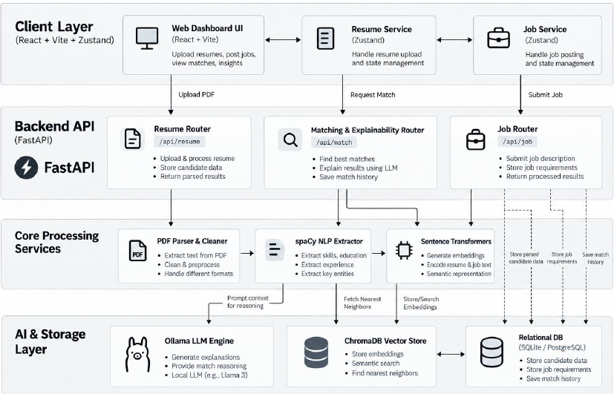

Fig. 1. VECTOR AI Resume Intelligence architecture.

A) User Interface and Application Layer

The frontend is developed using React, TypeScript, and Vite. It provides the interface through which users upload resumes, manage job information, view resume analysis, explore job recommendations, and access career-support features. The frontend communicates with the backend through API requests and displays the results returned by the processing components.

B) Resume Extraction and Pre-Processing Layer

This layer extracts readable text from uploaded resumes. PyMuPDF is used to process PDF documents, while EasyOCR supports image-based resumes in formats such as PNG and JPG. The extracted text is processed using spaCy to identify relevant information, including skills, qualifications, experience, and other resume details. This stage converts different resume formats into text that can be analysed by the subsequent components.

C) Semantic Representation and Job-Matching Layer

The system uses the all-MiniLM-L6-v2 sentence embedding model to convert resume content and job descriptions into numerical vector representations. These embeddings capture semantic relationships between text, allowing the system to compare candidate profiles with job requirements beyond exact keyword matches. ChromaDB stores job embeddings and associated metadata and supports similarity-based retrieval of relevant job opportunities. The matching components use the retrieved information to generate recommendations and assess candidate–job compatibility.

D) Resume Evaluation and Skill-Gap Analysis Layer

This layer evaluates the extracted resume information and generates a resume quality score using the implemented scoring rules. It also compares candidate skills with the requirements of relevant job opportunities to identify matched skills and missing skills. The system calculates skill-match information and combines skill and experience scores for candidate–job evaluation. These results support job recommendations, matching explanations, and suggestions for improving alignment with job requirements.

E) Data Storage and AI-Assisted Career Support Layer

SQLite stores application records and relevant information used by the application, while ChromaDB maintains vector representations and job metadata for semantic retrieval. Optional Gemini and Ollama integrations provide AI-assisted functions such as career chat and resume-improvement suggestions, depending on the configured provider. Where implemented, fallback logic allows certain features to operate without an external language-model provider. The final results are returned to the frontend for presentation to the user.

In summary, the architecture connects document extraction, natural language processing, semantic retrieval, resume evaluation, and career support in one application. The frontend and backend coordinate the workflow, while SQLite and ChromaDB serve different storage purposes. Unlike a system that only ranks resumes using keywords, VECTOR AI Resume Intelligence combines semantic job retrieval with structured resume scoring and skill-gap analysis to provide users with a broader understanding of their job suitability.

III. PROPOSED WORK

The proposed work focuses on developing an integrated resume analysis and job recommendation system that helps users understand their qualifications, identify suitable job opportunities, and recognize areas for improvement. Traditional resume screening methods often depend on exact keyword matching, which may fail to identify relevant skills when candidates express them using different terms. In addition, job recommendation alone may not explain why a candidate matches a role or which required skills are missing.

To address these limitations, VECTOR AI Resume Intelligence combines resume extraction, natural language processing, semantic retrieval, structured scoring, and AI-assisted career support. The system accepts resumes in PDF and image formats, extracts their text, and identifies relevant skills, qualifications, and experience. Sentence embeddings generated using all-MiniLM-L6-v2 support semantic comparison between candidate information and job descriptions. ChromaDB enables vector-based retrieval of relevant job opportunities, while the implemented scoring components evaluate resume quality and candidate–job compatibility. Skill-gap analysis identifies matched and missing skills, helping users understand how their profiles align with job requirements.

The system also provides job recommendations, matching explanations, resume improvement suggestions, and career guidance through optional Gemini and Ollama integrations. SQLite stores application records, while the React-based frontend presents the results through an interactive interface. The main contribution is the integration of resume evaluation, semantic job matching, skill-gap analysis, and career assistance within a single implemented application

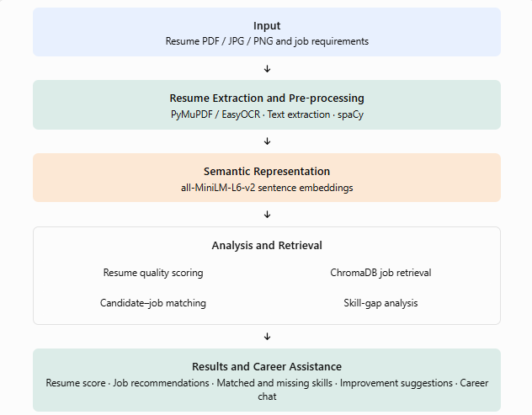
Fig. 2. Resume analysis and job recommendation workflow.

A. Algorithms and Pseudocode

1) Algorithm 1: Resume Extraction and Analysis

The first algorithm converts the uploaded resume into structured information. The system identifies the document format, extracts the text, and processes it to identify relevant resume details. The Input: Uploaded resume R

Pseudocode 1. Resume extraction and analysis

1. Identify the format of R

2. If R is a PDF:

Extract text using PyMuPDF

Else if R is an image:

Extract text using EasyOCR

3. Process extracted text using spaCy

4. Identify skills, qualifications and experience

5. Calculate the resume quality score

6. Store relevant application records

Output: Extracted resume information and quality score resulting information is used for resume scoring and subsequent job-matching operations.

2) Algorithm 2: Semantic Job Matching

The second algorithm represents resume information and job descriptions as sentence embeddings. These representations support semantic retrieval of relevant job opportunities using ChromaDB. The matching components then evaluate candidate–job compatibility using the implemented scoring logic.

Pseudocode 2. Semantic job matching

Input: Extracted resume information R, job collection J

1. Generate sentence embeddings for R

2. Retrieve relevant jobs using ChromaDB

3. For each retrieved job j:

Compare resume information with job requirements

Calculate the implemented skill-match score

Calculate the experience score

Combine scores using the implemented weighting

4. Rank candidate job matches

5. Identify matched and missing skills

6. Prepare recommendation explanations

Output: Ranked job recommendations and skill-gap results

3) Algorithm 3: Career Assistance and Result Presentation

The third algorithm prepares the results for the user and supports optional AI-assisted career features. Depending on the configured provider, the system may use Gemini or Ollama for career guidance and resume-improvement suggestions. The application also supports fallback logic where implemented.

Pseudocode 3. Career assistance

Input: Resume analysis A, job matches M, user request Q

1. Prepare relevant resume and job information

2. Display resume score and job recommendations

3. Display matched and missing skills

4. If AI assistance is requested:

Check the configured AI provider

Generate assistance using the available integration

Use the implemented fallback if required

5. Present the results through the frontend

Output: Resume insights, recommendations and career guidance

B. Input

The system accepts a resume in PDF, JPG, JPEG, or PNG format. The uploaded document is processed to extract information about the candidate's skills, educational qualifications, experience, and other relevant details. Job descriptions and stored job records provide the information required for matching. Users can then view resume analysis, recommended opportunities, and skill-gap results through the application interface.

Example input: A resume describing a candidate's Python programming, SQL, data analysis, and machine-learning skills. The system extracts these details and compares them with relevant job requirements to identify suitable opportunities and missing skills.

C. Output

The system produces several outputs based on the uploaded resume and available job information:

Resume quality score: An assessment based on the implemented resume-scoring rules.

Job recommendations: Relevant job opportunities retrieved and ranked by the matching process.

Matching information: Candidate–job compatibility scores and explanations supported by the implemented components.

Skill-gap report: Skills that match job requirements and skills that may be missing.

Career assistance: Resume-improvement suggestions and career guidance through the available AI integrations.

D. Bar Diagram and Explanation

The bar diagram presents a visual comparison of the key evaluation outputs generated by the VECTOR AI Resume Intelligence system. It illustrates the resume quality score, job match score, and skill match percentage to demonstrate how the system evaluates a candidate’s profile and its suitability for a selected job. The graphical representation makes it easier to compare these metrics and understand the candidate’s strengths and areas that may require improvement. The following diagram uses illustrative values tdemonstrate the presentation of the system’s outputs.

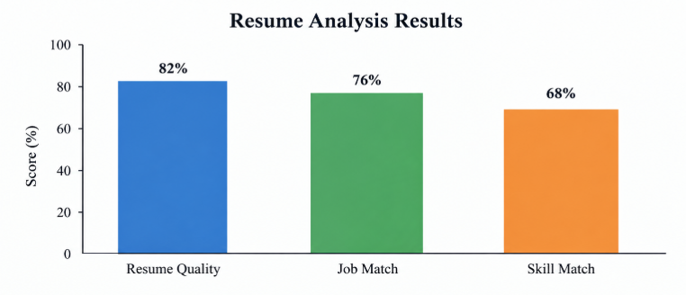
Fig. 3. Illustrative resume quality, job match, and skill match scores.

The bar diagram illustrates three key outputs of the VECTOR AI Resume Intelligence system: resume quality score, job match score, and skill match percentage. In this illustrative example, the resume quality score is 82%, indicating the overall quality of the candidate’s resume. The job match score is 76%, representing the compatibility between the candidate’s profile and a selected job. The skill match percentage is 68%, showing the extent to which the candidate’s skills correspond to the job requirements. These results demonstrate how the system can present resume evaluation and job matching information in a simple visual format, helping candidates identify their strengths and areas for improvement.

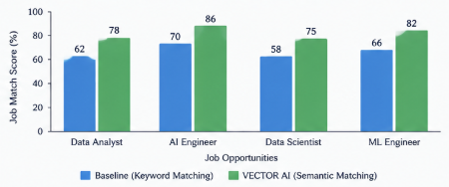
Fig. 4. Job recommendation workflow.

The job recommendation workflow illustrates how VECTOR AI Resume Intelligence identifies suitable job opportunities for a candidate. The system extracts relevant information from the uploaded resume, including skills, qualifications, and experience. It converts the extracted information into semantic embeddings and uses vector-based retrieval to identify relevant job descriptions. The retrieved jobs are evaluated based on skill compatibility and experience, and the system presents ranked recommendations to the user. This workflow helps candidates identify job opportunities that align with their qualifications and professional skills

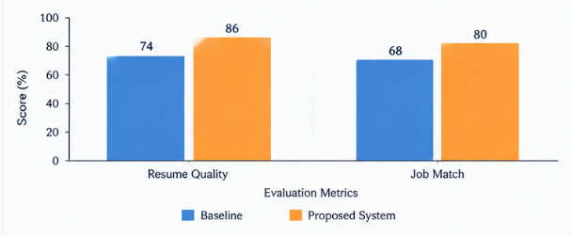
Fig. 5. Resume evaluation and job matching.

The resume evaluation and job matching diagram presents the two main evaluation outputs provided by VECTOR AI Resume Intelligence. The resume quality score reflects the assessment of resume components such as skills, experience, education, projects, and certifications. The job match score indicates the compatibility between the candidate’s profile and a selected job, based on the implemented matching criteria. By presenting these results together, the system helps candidates understand the quality of their resume and its relevance to specific job opportunities.

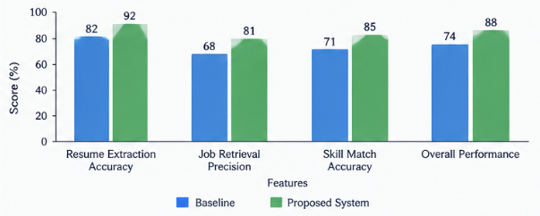
Fig. 6. Feature-wise system performance comparison.

The feature-wise performance comparison illustrates how different components of the VECTOR AI Resume Intelligence system contribute to resume evaluation and job recommendation. The diagram compares resume information extraction, job retrieval, skill matching, and overall system performance. These components support the process of extracting relevant candidate information, identifying suitable job opportunities, and evaluating compatibility between resumes and job requirements. The comparison helps explain the role of each component in the overall system.

IV. CONCLUSION AND FUTURE WORK

A. Conclusion

VECTOR AI Resume Intelligence is an implemented system designed to simplify resume evaluation and job recommendation through natural language processing, semantic embeddings, and vector-based retrieval. The system extracts relevant information from resumes in PDF and image formats and analyses skills, qualifications, experience, projects, and certifications. It provides resume quality scoring, job recommendations, skill-gap analysis, matching explanations, resume improvement suggestions, and AI-assisted career guidance through an integrated web application.

The combination of React, FastAPI, SQLite, ChromaDB, and sentence embeddings enables the system to connect resume information with relevant job descriptions and present useful results to candidates. By combining resume assessment and job matching with skill-gap identification, the application helps users understand their suitability for job opportunities and identify areas for improvement. The completed implementation demonstrates the practical integration of NLP and semantic retrieval techniques into a resume intelligence application.

B. Future Work

Future improvements may focus on expanding the job dataset, evaluating the system using larger and more diverse resume collections, and measuring matching quality through standard evaluation metrics such as precision, recall, and F1-score. The matching process could be enhanced using cross-encoder reranking and more advanced semantic models. Further work could also introduce bias detection, fairness evaluation, multilingual resume processing, secure user authentication, and privacy controls. Integration with live job portals and personalised learning recommendations could extend the system's usefulness for job seekers. These improvements would help enhance the reliability, scalability, security, and practical applicability of VECTOR AI Resume Intelligence.

V. REFERENCES

[1] “An Advanced Real-Time Job Recommendation System and Resume Analyser,” in 2023 International Conference on Self Sustainable Artificial Intelligence Systems (ICSSAS), IEEE, 2023, doi: [10.1109/ICSSAS57918.2023.10331788](https://doi.org/10.1109/ICSSAS57918.2023.10331788.

[2] “ResumAI: Revolutionizing Automated Resume Analysis and Recommendation with Multi-Model Intelligence,” in 2023 Global Conference on Information Technologies and Communications (GCITC), IEEE, 2023, doi: 10.1109/GCITC60406.2023.10426042.

[3] Y. Huang, D.-R. Liu, and S.-J. Lee, “Talent recommendation based on attentive deep neural network and implicit relationships of resumes,” Information Processing & Management, vol. 60, no. 4, Art. no. 103357, 2023, doi: 10.1016/j.ipm.2023.103357.

[4] H. Artajaya et al., “Job Recommendation System based on Resume using Natural Language Processing and Distance-based Algorithm,” in 2024 IEEE International Conference on Artificial Intelligence and Mechatronics Systems (AIMS), IEEE, 2024, doi: 10.1109/AIMS61812.2024.10512474.

[5] A. Mishra, S. Singh, and R. C. Jisha, “AI-Powered Model for Intelligent Resume Recommendation and Feedback,” in 2024 15th International Conference on Computing Communication and Networking Technologies (ICCCNT), IEEE, 2024, doi: 10.1109/ICCCNT61001.2024.10726016.

[6] X. Yu, J. Zhang, and Z. Yu, “ConFit: Improving Resume-Job Matching using Data Augmentation and Contrastive Learning,” in Proceedings of the 18th ACM Conference on Recommender Systems (RecSys ’24), 2024, doi: 10.1145/3640457.3688108.

[7] Y. Gao et al., “Retrieval-Augmented Generation for Large Language Models: A Survey,” arXiv preprint arXiv:2312.10997, 2023, revised 2024. [Online]. Available: https://arxiv.org/abs/2312.10997

[8] Z. Jiang et al., “Active Retrieval Augmented Generation,” in Proceedings of the 2023 Conference on Empirical Methods in Natural Language Processing (EMNLP), 2023, pp. 7969–7992, doi: 10.18653/v1/2023.emnlp-main.495.

[9] “Development of a Recommendation System for Resume Tracking and Job Suggestions,” in 2024 IEEE International Conference on Distributed Computing and Electrical Circuits and Electronics (DELCON), IEEE, 2024, doi: 10.1109/DELCON64804.2024.10866841.

[10] “Career Craft AI: A Personalized Resume Analysis and Job Recommendations System,” in 2024 IEEE International Symposium on Technology and Engineering Management Systems (ISTEMS), IEEE, 2024, doi: 10.1109/ISTEMS60181.2024.10560126

[11] “Optimizing Job Matching Through Automated Resume Screening with NLP and Machine Learning,” in 2024 IEEE International Conference on Intelligent Signal Processing and Effective Communication Technologies (INSPECT), IEEE, 2024. doi: 10.1109/INSPECT63485.2024.10896014.

[12] X. Yu, R. Xu, C. Xue, J. Zhang, X. Ma, and Z. Yu, “ConFit v2: Improving Resume-Job Matching using Hypothetical Resume Embedding and Runner-Up Hard-Negative Mining,” arXiv preprint arXiv:2502.12361, 2025. [Online]. Available: https://arxiv.org/abs/2502.12361.

[13] “A Survey on Artificial Intelligence (AI) based Job Recommendation Systems,” in 2023 IEEE International Conference on Smart Computing and Systems Design (ICSCDS), IEEE, 2023. doi: 10.1109/ICSCDS56580.2023.10104718.

[14] “Nexus: A Multi-Modal Framework for Semantic Job Matching and AI-Driven Resume Analysis,” Procedia Computer Science, vol. 283, pp. 922–935, 2026. doi: 10.1016/j.procs.2026.06.173.

[15] Z. Jiang et al., “Active Retrieval Augmented Generation,” in Proceedings of the 2023 Conference Empirical Methods in Natural Language Processing, pp. 7969–7992, 2023. doi: 10.18653/v1/2023.emnlp-main.495

